**Homework on SML and PROLOG**

To do alone or in a team of 2 students.

**SML**

1. What are the types of the following expressions?

* [(1,5), (2,3), (5,6)]; ANSWER: int*int list
* fun f(x:real) = true; ANSWER: real -> boolean
* map f; ANSWER: real list -> bool list

1. Provide expressions of the following types:

* int * bool (3, true)
* int list * bool ([1,2,3], true)
* int * real -> bool list fun f(x:int*real) = [true,false]

1. Write the following SML functions:



fun recpow(x) = if x = 0 then 1 else 2 * recpow(x-1);

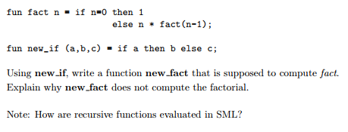

fun new_fact(n) = new_if(n=0,1,n*new_fact(n-1));

This does not work because SML uses innermost evaluation. Therefore, the inner new_fact gets evaluated causing an infinite loop. Innermost evaluation does not always terminate, such as in this case. It will keep calling new_fact(n-1) forever.

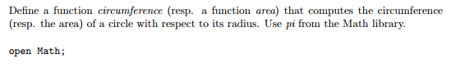

fun circumference(r) = 2.0 * pi * r;

How to use map to add 3 to each elements of a list

val nums = [1,2,3,4,5];

fun increment(x) = x + 3;

map increment nums;



fun FirstToLast(nil) = nil

|FirstToLast(lst) = tl lst @ [hd lst];

1. Implement the datatype BinaryTree and all the functions that are provided in the lecture notes: lookup, inorder, preorder, postorde, left_subtree, right_subtree and label. Provide screenshots to show that your code is correct. Provide 2 tests for each function.

